**This is an assignment to practice basic and important C# knowledge.**

**Requirement**: Create a Console application for an electronic grade book to read grades of an individual student:

1. Show options to save the grade book in memory (InMemoryBook) or in a file (DiskBook)
2. Then compute some simple statistics from the scores
3. The grades must be floating point numbers from 0 to 100
4. Statistics should show the highest grade, lowest grade, and the average grade

**Constraints:**

* Use pillars of OOP (Inheritance, Polymorphism, Encapsulation, Abstraction) - interface, abstract classes, delegate and event
* Catch exception in case users enter invalid grades using try catch

**Results:**

Save the grade book in memory:

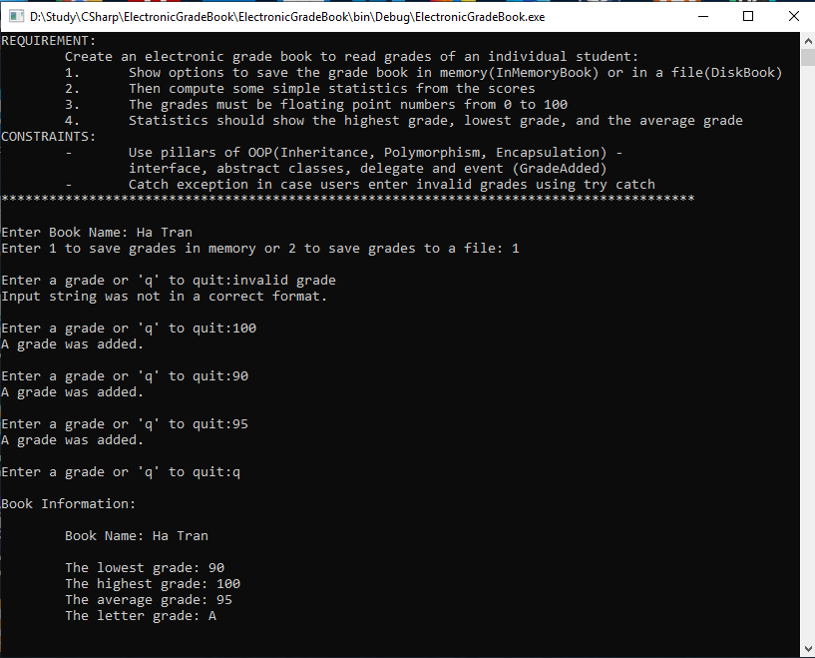

Save the grade book in a file

